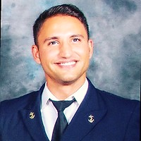

**NOME E COGNOME**

CHIEF OFFICER

*DESCRIVI TE STESSO*

**PERSONAL**

**FULL NAME:**

**NATIONALITY:**

**CITYZEN:**

**BIRTH DATE:**

**STATUS:**

**PASSPORT:**

**ABOUT ME IN SHORT**

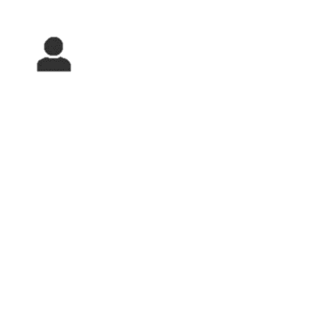

**WORK EXPERIENCE**



**ULTIMO LAVORO**

PRIMO



● ●

**2019**

**CONTACT**

**Email :**

**Telephone:**

**SKIPE: marco.polito5**

**LINKEDIN:** linkedin.com/in/marco-polito1985

**STAGES**

PRIMO LAVORO

**2005**



**LANGUAGES**

**EDUCATION**



1. ITALIAN (●●●●●)
2. English (●●●●●)
3. Spanish (●●●●o)
4. Portuguese (●●●●●)

**DIPLOMA**

2005 Graduated in Maritime School of Naples (Italy) “Duca degli Abruzzi” Certification of Navigation Officer.

**HIGH SCHOOL**

**CERTIFICATES**



**HIGHLIGHTS**

**ATTESTATI EXTRA**

**HOBBIES**

**OTHERS**

**CERTIFICATES**